**Wpf Clock App**

I wrote this app in C# and WPF, beginning with a sample clock app downloaded from the Web. Since getting the original version built and running, I’ve made numerous enhancements to it based on using it and getting ideas for improvements. One of the first enhancements was adding a date in 3 different formats:

1. Long: Thursday, February 23, 2017
2. Short: Thu 2/23/2017
3. ISO 8601 (with day of week): Thu 2017-02-23

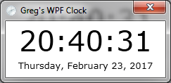

Also added 12-hour display as an option:

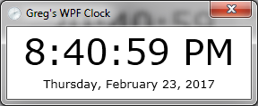

Then I got rid of the title bar to reduce the desktop real estate it took up:

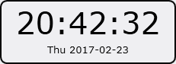

… made the date optional



… and added variable opacity to the background

100%

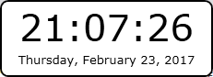

75%

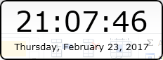

50%

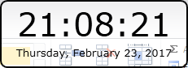

25%

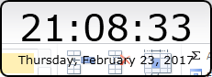

See-through

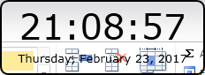

Then I added code to increase the border thickness …

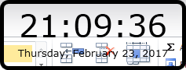

… and decrease it, all the way to 0

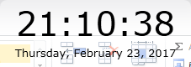

Then I added the Vista “glass” background

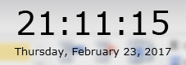

I also added options to make the app dragable or not, make it stay on top or not, and to copy the time, date, or both to the clipboard. I’ve got a long list of planned enhancements so what’s here is just the beginning.

Comments and suggestions may be sent to me at greg02@pobox.com.